**JUNIX Connector – User Manual**

**About this Manual**

This manual is intended to guide the associates who are using Junix connector program to connect and execute commands in UNIX server.

**Pre-requisite to Use the Junix connector:**

1. This program requires JRE or JDK to run.
2. This program requires Jsch jar and which also needs to be included in the class path while execution. <http://www.jcraft.com/jsch/> download the Jsch in the given link.
3. Configuration file which contain username, password and server details to connect to the server.

**Steps:**

1. Execute the jar file using following command

**java -cp "UnixConsole.jar;." Log.UnixConsole.JobConsole**

1. Below screen will appear

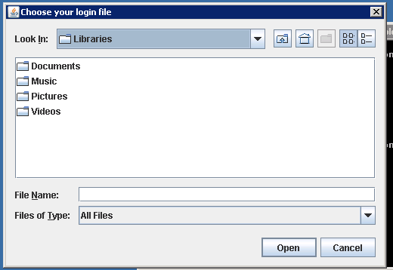

User needs to select the configuration file which contains server name or IP , user name , password and port for that server.

**Configuration file model**

|  |
| --- |
| **192.168.170.120 username password 22**  **192.120.159.12 username password 22** |

1. Below screen will appear , after successful connections to the servers

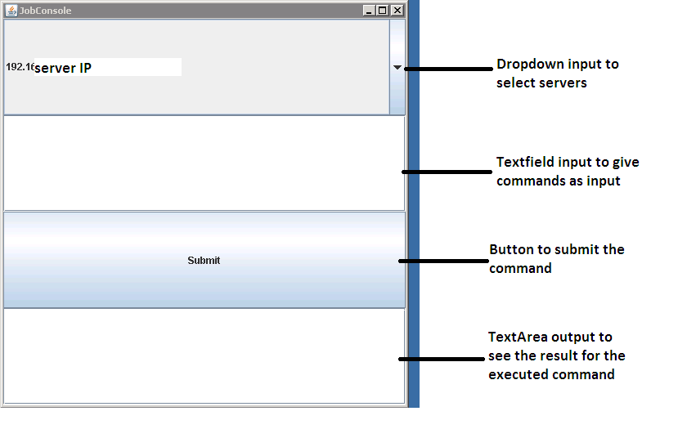

1. Select the server from the Dropdown and enter the command in text field and click submit button to execute the command on respective server and check the output in the below field.

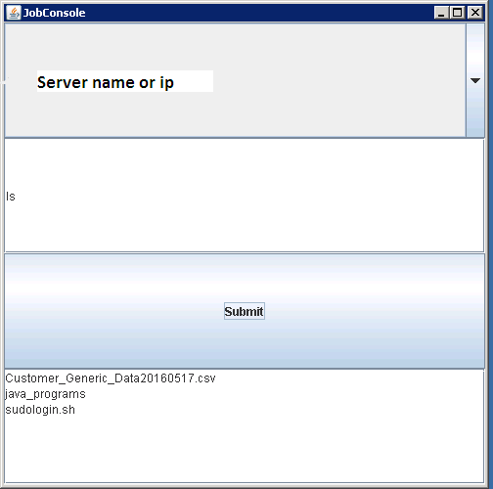

**How to execute the source files:**

1. Compile the below files in order

**Javac SwingConsole.java**

**Javac Server.java**

**Javac –cp “jsch_jar_name.jar;.” Bridge.java**

**Javac –cp “jsch_jar_name.jar;.” JobConsole.java**

1. Execute the program by

**Java –cp “jsch_jar_name.jar;.” JobConsole**

And follow the above procedures from step 2.

**Brief Explanation of Design:**

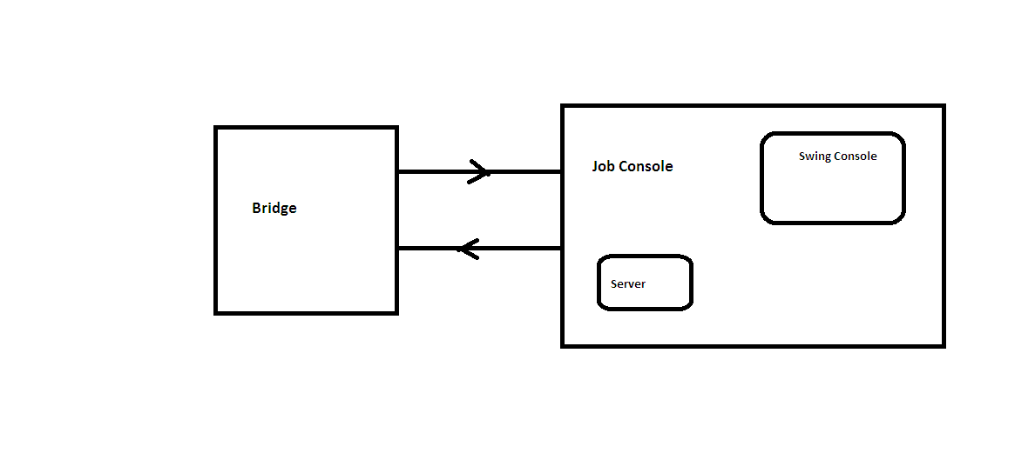

The entire System consists of two modules

1. User interface
2. Bridge

**Mechanism:**

* JobConsole program is responsible for User Interface module, which acts as a View and also as a Controller.
* JobConsole get input from the User Interface and sends it to the respective unix server for execution using Bridge objects.
* Once Bridge executes the command in the respective server and sends the result back to User Interface for displaying the result in the front end.